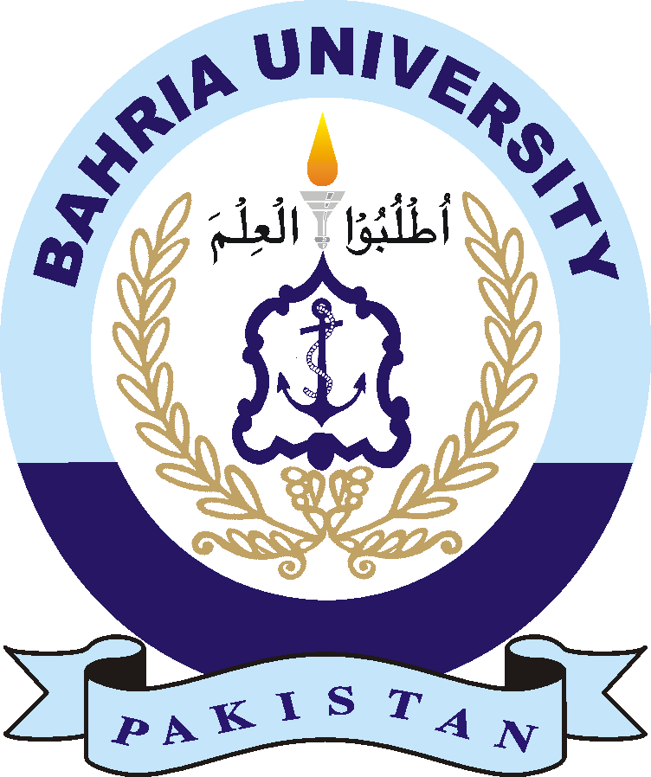

**BAHRIA UNIVERSITY (KARACHI CAMPUS**)

Engineering Management (MGT-423)

ASSIGNMENT # 2 – SPRING 2024

Class: **BSE-04** Submission Date: **27th April, 2024**

Course Instructor: **Asim Iqbal** Max Marks: **05**

**(CLO – 1)**

Student Name: ___________________________ Reg. No: ______________

**Question 1**: **Answer the following questions. You may make use of any case study discussed in class or that you have studied with reference:**

1. **Why is it so important for an engineer today to have knowledge of Research and Development?**

1. **How do you manage the R&D process to align with strategic business goals?**
2. **What does it mean to be Corporate Research?**
3. **Why do companies have a Corporate Research Functions?**
4. **Difference between Technical Personnel and Business Personnel?**